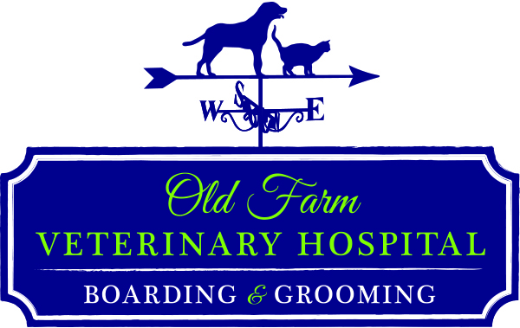
100 Tuscanny Dr. Suite A, Office Hours by Appointment
(Hospital Use Only) Chart #__________
Frederick MD 21702 Mon-Fri 7am – 7pm
(p) 301-846-9988 Sat: 7am – 12pm
(f) 301-846-9912 Excluding Holidays
info@oldfarmvet.com oldfarmvet.com

Patient / Client Information

Name/Title Spouse/Other
Address________________________________ City______________ State_____ Zip_______
Primary Telephone Secondary Phone______________________
Spouse’s Telephone Email ______________________________
Driver’s License # and State___________________________________ (for check payment)
Are you active duty military? _____ (If yes, please show military ID to the Receptionists or email a photo at info@oldfarmvet.com)
How did you learn about our hospital? We would like to thank any individual who referred you.
Hospital Sign Yellow Pages Web Search AAHA Personal Referral by: ________________________________
At your request we will gladly discuss cost of services and/or prepare an estimate for recommended procedures.
24 hour supervision is not available for any animals in our care.
To assure consistent quality of products we cannot accept returns on any items not sealed in the original manufacture packaging. We will accept open food products in accordance with manufacture return guidelines.

Fees are DUE at the time services are rendered
- A deposit may be required for services at the time of drop off.
- A deposit of $35.00 will be collected at the time of scheduling surgeries, grooming and boarding services.
- We accept Cash, Checks, Debit, Visa, MasterCard, Discover and Care Credit.
- Checks must be authorized by Telecheck. We charge a $35.00 fee for returned checks.

State law requires rabies vaccination for everyone’s safety. To prevent the spread of infectious disease, all pets admitted for boarding, grooming and hospitalization are required to be current on vaccinations for transmissible diseases. We assume no liability for pets or humans contracting infectious diseases or parasites. Pets with fleas will be treated upon admission; the cost will be included on the invoice.

We require that all pets remain either on a leash or in a carrier until instructed otherwise by a staff member. If you do not have a leash or a carrier, we will provide one for you at a fee.

I Authorize Administration of Required Vaccines and Parasite Control as Needed for my Pets.
I understand that I am responsible for cost of all services performed at Old Farm Veterinary Hospital.
I agree that I have been given the opportunity to discuss fees and recommended procedures with the Doctors or Staff of OFVH. Unless otherwise specified, I authorize release of medical records for the following services on request such as boarding, grooming, referrals to other veterinarians, or for other purposes

SIGNATURE: Date:
Please complete individual pet information on the back of this form
Animal Identification and Medical Information

 | Pet #1 | Pet #2 | Pet #3
Name
Species (Cat/Dog)
Breed
Description/Color
Age/Date of Birth
Male or Female?
Are they neutered or spayed?
Time Owned
How Obtained
Can we use your pet’s photo on social media?
(usually used for boarding and grooming clients)
Have they been microchipped?
Current Medications and Supplements
Are they on a Prescription Diet?
Any prior surgeries?
Previous Veterinarian

Details/Prior Illness/Accidents:

